Función Básica I

|  |  |
| --- | --- |
| Function a() | |
| return | 35 |
|  |  |

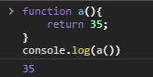function a(){

return 35;

}

console.log(a())

Output:

35

|  |  |
| --- | --- |
| Function a() | |
| return | 4 |
| a()+a() | 4+4=8 |

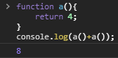

function a(){

return 4;

}

console.log(a()+a());

Output:

8

|  |  |
| --- | --- |
| Function a(b) | |
| b | 2 – 4 |
| a(2)+a(4) | 2+4=6 |

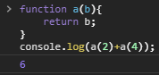

function a(b){

return b;

}

console.log(a(2)+a(4));

Output:

6

|  |  |
| --- | --- |
| Function a(b) | |
| b | 3 |
|  |  |

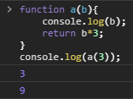

function a(b){

    console.log(b);

return b*3;

}

console.log(a(3));

Output:

3,9

|  |  |
| --- | --- |
| Function a(b) | |
| b | 10 |
|  |  |

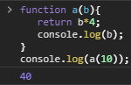function a(b){

return b*4;

console.log(b);

}

console.log(a(10));

Output:

40

|  |  |
| --- | --- |
| Function a(b) | |
| b | 15 |
| if | |
| b<10 | 15<10 |

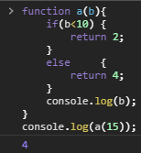function a(b){

if(b<10) {

return 2;

}

    else {

return 4;

}

console.log(b);

}

console.log(a(15));

Output:

4

|  |  |
| --- | --- |
| Function a(b,c) | |
| b | 3 |
| c | 10 |
| b*c | 3*10=30 |
|  |  |

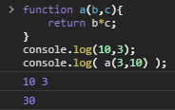function a(b,c){

return b*c;

}

console.log(10,3);

console.log( a(3,10) );

Output:

10,3,30

|  |  |
| --- | --- |
| Function a(b) | |
| b | 3 |
| b | 4 |
|  |  |

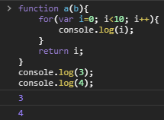function a(b){

for(var i=0; i<10; i++){

console.log(i);

}

return i;

}

console.log(3);

console.log(4);

Output:

3,4

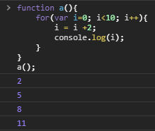

|  |  |
| --- | --- |
| Function a() | |
| i | 0->3->6->9 |
| i = i + 2 | 2->5->8->11 |

function a(){

for(var i=0; i<10; i++){

i = i +2;

console.log(i);

}

}

a();

Output:

2,5,8,11

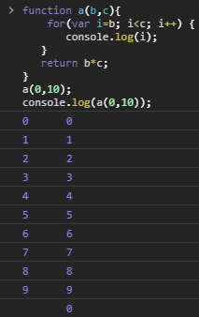

|  |  |
| --- | --- |
| Function a(b,c) | |
| b | 0 |
| c | 10 |
| i | 0->1->2->3->4->5->6->7->8->9 |

function a(b,c){

for(var i=b; i<c; i++) {

console.log(i);

}

return b*c;

}

a(0,10);

console.log(a(0,10));

Output:

0,1,2,3,4,5,6,7,8,9,

0,1,2,3,4,5,6,7,8,9,0

|  |  |
| --- | --- |
| Function a() | |
|  |  |
|  |  |
|  |  |

function a(){

for(var i=0; i<10; i++){

for(var j=0; j<10; j++){

console.log(j);

}

console.log(i);

}

}

Output:

No se llama a la función

|  |  |
| --- | --- |
| Function a() | |
|  |  |
|  |  |
|  |  |

function a(){

for(var i=0; i<10; i++){

for(var j=0; j<10; j++){

console.log(i,j);

}

console.log(j,i);

}

}

Output:

|  |  |
| --- | --- |
| Function a() | |
| z | 10 |
|  |  |

No se llama a la función.

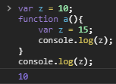var z = 10;

function a(){

var z = 15;

console.log(z);

}

console.log(z);

Output:

10

|  |  |
| --- | --- |
|  | |
| z | 10 |
| function a() | |
| z | 15 |

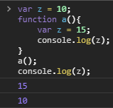var z = 10;

function a(){

var z = 15;

console.log(z);

}

a();

console.log(z);

Output:

15,10

|  |  |
| --- | --- |
|  | |
| z | 10 |
| function a() | |
| z | 15 |

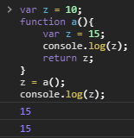var z = 10;

function a(){

var z = 15;

console.log(z);

return z;

}

z = a();

console.log(z);

Output:

15,15